
Human Biology – General Year 11 Task 10 – Unit 2
Name: _________________________________
Assessment type: Practical
Conditions:
Period allowed for completion of the task:
- One lesson in class demonstrating/ explaining practical
- One lesson conducting practical in class
Task weighting: 10% of the school mark for Units 1 and 2 ___________________________________________________________________________ Task 10: Practical- Rat Dissection (29 marks)

Part One: Dissection
- Follow the procedure given on the laminated sheets concerning the rat dissection.
- Once that is completed move your focus to the reproductive systems. Steps 3 and 4 concern the male reproductive system, and steps 5 and 6 concern the female reproductive system.
- The major reproductive organs of the male rat are the testes (singular: testis) which are located in the scrotal sac. Cut through the sac carefully to reveal the testis. On the surface of the testis is a coiled tube called the epididymis, which collects and stores sperm. The tubular vas deferens moves sperm to the urethra, which carries it though the penis and out the body.
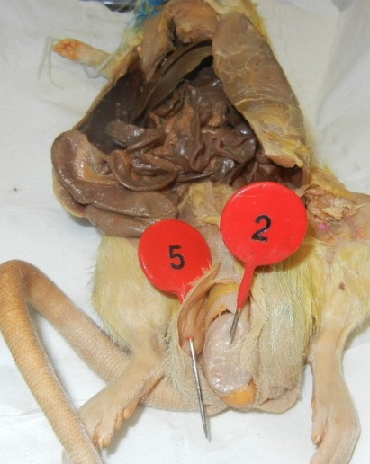
- The lumpy brown glands located to the left and right of the urinary bladder is the seminal vesicles. The gland below the bladder is the prostate gland and it is partially wrapped around the penis. The seminal vesicles and the prostate gland secrete materials that form the seminal fluid (semen). Pin the organs of the urogenital system.

The short grey tube lying dorsal to the urinary bladder is the vagina. The vagina divides into two uterine horns that extend toward the kidneys. This duplex uterus is common in some animals and will accommodate multiple embryos (a litter). In contrast, a simple uterus, like the kind found in humans has a single chamber for the development of a single embryo.

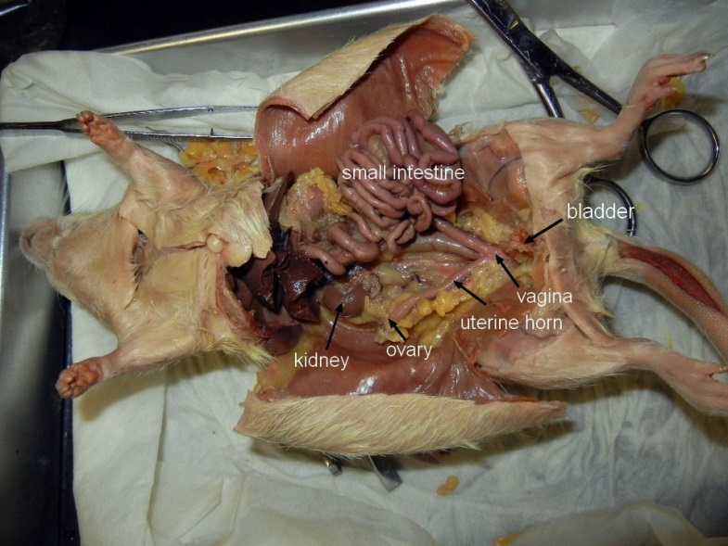
At the tips of the uterine horns are small lumpy glands called ovaries, which are connected to the uterine horns via oviducts

- Follow clean up instructions from your teacher.
Part Two: Discussion of practical
- What materials did you use in the practical? (2 marks)
_________________________________________________________________________________________________________________________________________________________________________________________________________________________________________________________________________________________________________________________________________________________

- How could you tell the sex of your rat? (2 marks)
_________________________________________________________________________________________________________________________________________________________________________________________________________________________________________________________________________________________________________________________________________________________

- Complete the following diagram by labelling the noted areas of a male dissected rat (7 marks)
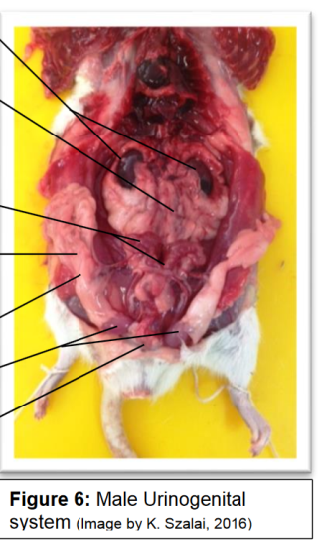

- Define the following terms: (8 marks)
  - Bladder:
______________________________________________________________________________________________________________________________
  - Penis:
______________________________________________________________________________________________________________________________
  - Rectum:
______________________________________________________________________________________________________________________________
  - Seminal vesicle
______________________________________________________________________________________________________________________________

  - Testes
______________________________________________________________________________________________________________________________
  - Ovaries
______________________________________________________________________________________________________________________________
  - Uterus
______________________________________________________________________________________________________________________________
  - Vas Deferens:
______________________________________________________________________________________________________________________________

- Explain the process of egg fertilisation, starting with the production of the egg. (10 marks)
_________________________________________________________________________________________________________________________________________________________________________________________________________________________________________________________________________________________________________________________________________________________
_________________________________________________________________________________________________________________________________________________________________________________________________________________________________________________________________________________________________________________________________________________________
_________________________________________________________________________________________________________________________________________________________________________________________________________________________________________________________________________________________________________________________________________________________
_________________________________________________________________________________________________________________________________________________________________________________________________________________________________________________________________________________________________________________________________________________________
_______________________________________________________________________________________________________________________________________________________________________________________________________________

